Terms of Reference

Technical Assistance for Road Safety Management Capacity Review (RSMCR) and improvements of road safety management capacity at municipality level (Local Communities)

LRCP-9034-MK–CS-CQS-A.1.2.3

April 2021

Table of Contents
1 Background 3
2 Objectives of the Assignment 7
3 Scope of services 7
4 Period of implementation of Services 13
5 Reporting Requirements 14
6 Project management 16
7 Payment schedule 16
8 Company profile and qualification criteria 17
9 Law and Language 21

Background
North Macedonia is a landlocked country at the heart of the Balkans characterized by mountainous terrain intersected by valleys and lowlands. As a transit region traversed by two of the ten Pan-European transport corridors, Corridor VIII and Corridor X, its proximity to the European Union (EU) potentially provides the country with access to a large export market of 650 million customers. According to the last census of 2002, the population is about two million, of which 25 percent live in the capital Skopje, 40 percent reside in rural areas, and the remaining share live in smaller urban centers.
Infrastructure investment levels in North Macedonia have been low over the past 10 years. The Government’s infrastructure plan, the National Program 2017–2020, focuses on providing infrastructure in support of a modern economy. The main goals for the transport sector are to improve connectivity so that travel between economic centers takes less than 90 minutes, tackle accident blackspots/high risk road sections, and achieve a local road network that is ‘without mud’. The Government’s vision also anticipates that large investment projects will be developed transparently and through consultation with citizens.
As North Macedonia’s economy picks up, car ownership is likely to increase even more rapidly. Motorization rates for the enlargement countries in 2017 were considerably lower than in the EU-28. In North Macedonia there were, on average, 195 passenger cars per 1 000 inhabitants compared to EU-28 average of 524. In comparison, the lowest recorded motorization rates in Western Balkans were in Kosovo, Turkey and Albania, below 160 passenger cars per 1 000 inhabitants. During 10-year period, motorization rate grew faster in nearly all enlargement countries (except Montenegro) then in EU-28. In 2010, North Macedonia has 151 passenger vehicles per 1.000 habitants, while in 2018 that number was increased up to 200 (this indicates growth from 2010 to 2018 of 32%). The enlargement countries with the lowest motorization rates in 2017 - Albania, Turkey, Kosovo and North Macedonia — recorded the fastest expansions in car ownership between 2007 and 2017.
Without proper road safety measures, traffic fatalities would increase. Number of traffic accidents has decreased for 11% comparing 2010 and 2018. Total number of killed persons decreased by 18% and injured persons by 8% in the same period. However, this was not a steady downward trend, several peaks occurred in years in between. In 2017 comparing to 2016, number of accidents grew by 3% and number of injured persons by 4% showing necessity of sustainable road safety planning and implementation.
There are several responsible bodies for road safety in the Republic of North Macedonia. National Government coordinates activities for implementation of the National Strategy for Road Safety through a National Coordination Body for road safety. Ministry of Transport and Communications is highest state body in the area of transport including road safety at national level also responsible for technical regulations and standards for design and construction of roads including road signalization and equipment. The Ministry of Interior is in charge of establishing and maintaining a central registry of identified accidents. Traffic Police within the Ministry of Interior is in charge of law enforcement and traffic safety on the roads. Public Enterprise for State Roads, owner of the national and regional road infrastructure, is responsible for planning the construction, reconstruction, maintenance, operation and protection of the state roads, monitoring and analysis of the conditions in relation to the construction, reconstruction, maintenance and protection of the state roads. Public enterprise for maintenance of public roads PE "Makedonija pat“ is in charge of regular and winter maintenance of state roads, construction and installation of vertical and horizontal signaling, protection of roads. The City of Skopje as special local-self-government unit as well as the municipalities are responsible for planning, improving, maintaining, and regulating its own local road network.
Republic Council on Road Traffic Safety (RCRTS) is an advisory body of the National Assembly (Parliament) of North Macedonia. The President and the members of the RCRTS are appointed by the Parliament for a period of 4 years. The Council deals with promotion and development of traffic education, culture and ethics of all participants in road traffic as well as with other measures to improve safety of the roads. RCRTS in cooperation with all relevant stakeholders has prepared, and the Parliament adopt the First National strategy for improving the road safety for period 2009 - 2014 and the Second National strategy for improving the road safety in 2015 - 2020. The objective of the Second National Strategy 2015-2020 was to reduce the number of victims in road accidents to be in line with the average number of victims in the European Union (EU) Member States (MS), the number of victims - young drivers should be reduced by 30%, the number of seriously injured should be reduced by 40%, and the number of children - victims in the road traffic shall be reduced to zero. Unfortunately, none of those, very ambitious goals were achieved until 2020. The data says that from 2015 to 2019 number of fatalities was decreased by 11% and number of injuries was decreased by 13%. The Government recognizes the need to develop a road safety strategy for the period 2021-2025 as well as road safety policies, implementation action plans with mechanisms, and monitoring systems, but it is a lack of technical and financial support.
There are also several Municipal Councils on Road Safety at local level established by municipalities according the road traffic safety law. These bodies act as advisory body of the municipal councils and deal with promotion and development of traffic education, culture and ethics of all participants in road traffic as well as with other measures to improve road safety at municipal level. However, due to lack of stable financing streams and local capacities, impact of these councils was limited and should be strengthened.
Draft National Transport Strategy 2030 emphasizes establishment of reliable and safe transport system as one of the main objectives. Road safety and improvement of road traffic and road infrastructure safety has been given pivotal role. In the National Strategy, the government commits to halving the number of fatal and serious road traffic injuries from 2020 to 2030, in line with the fatality and injury targets applied in the EU and at the UN level, and adopts the necessary complementary measures to reach these targets.
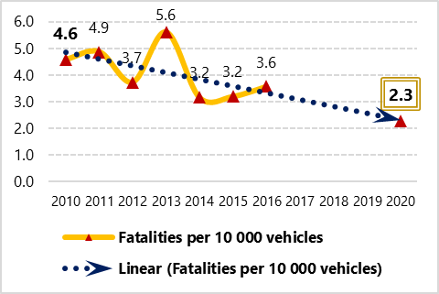
Figure 1: fatalities per 10000 vehicles and trend (source: SEETO)
On a regional level, in 2017 EU funded project "Connecta", implemented via SEETO, prepared Road Safety Inspection (RSI) and Audit (RSA) Plans for core/comprehensive network in Western Balkans (WB6) and Pilot Projects. The purpose of this TA was to prepare short-term plans (2018-2020) for road safety inspection and audit for the whole Core and Comprehensive Road Network in the Western Balkans. In parallel EU Project/Study, "Monitoring of the road safety strategies in SEETO members and draft a regional short term action plan" was implemented with initial benchmarking of road safety in each SEETO Participants. Study proposed key areas of needed road safety activities within each Participant.
Figure 2: overall implementation of EU 7 strategic road safety objectives (Source SEETO, 2017)
The Ministry of Transport and Communications (MoTC) is committed to addressing road safety in North Macedonia. Recent efforts consisted in road safety audits on key corridors. Lately (in 2020), MoTC start implementation of small-scale EU project (Technical Assistance) related to the establishment of the executive body for road safety. The Project shall result with establishing key lead body responsible for road safety management at national level and its key functions.
Table 1: Initial assessment of institutional arrangement, capacity, funding and coordination within SEETO Regional Participants
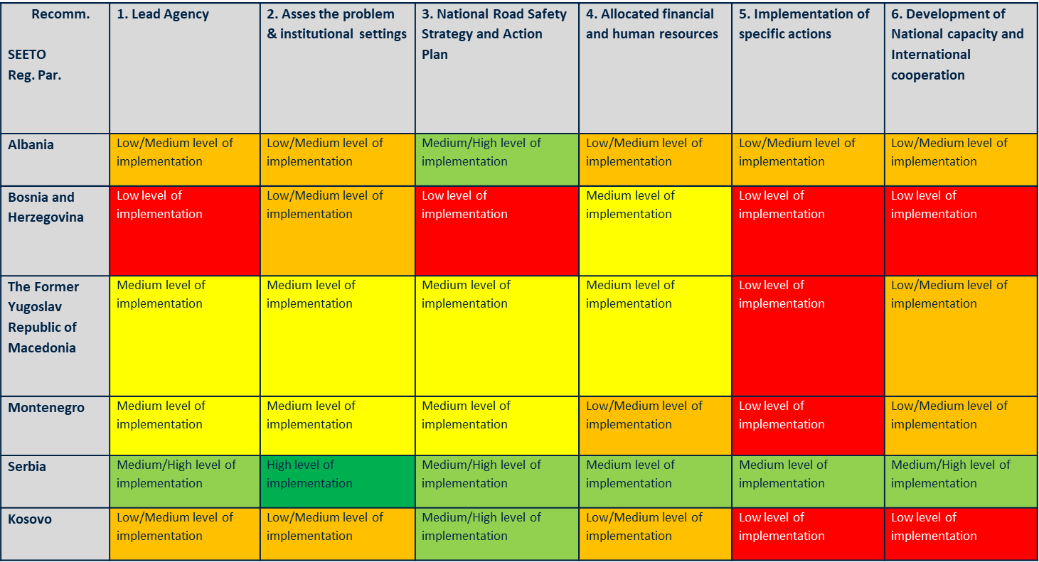
Beside all specified road safety initiatives and in the context of the Local Roads Connectivity Project, the Ministry of Transport and Communications has expressed its strong interest for improvement of road safety management in North Macedonia at National level, as well as in municipal level (local communities) where IFI's (especially World Bank) road safety experience is more than welcome.
Actually, knowing that great number of accidents (deaths) occurred on urban roads (the local streets and the sections of roads passing through the city or municipality), it is essential that safety activity is strengthened at municipal level so they can improve roads and safety under their jurisdiction. This is also in line with EU challenge on road safety “Think global and act local”.

Objectives of the Assignment
The objective of this assignment is to support the Government of North Macedonia and Ministry of Transport and Communications in conducting Road Safety Management Capacity Review followed by preparation of detailed investment strategy and identification of safe system implementation projects and translated into comprehensive action plan for implementation of recommendations proposed through the review and investment strategy. The review should also cover road safety management capacity at municipality level (local communities). The Road Safety Management Capacity Review (RSMCR) should assess all past and ongoing efforts (especially the EU funded on lead agency), identify missing links and synergies among initiatives, recommend further institutional and technical actions that should support and help monitor the current and future efforts, provide detailed guidance to the national and local governments, etc.

The assignment, especially linking the recent development in the area of the road safety governance and improvement or road safety management capacity at local communities, will provide the missing link in road safety management in North Macedonia and enable permanent reduction of road fatalities and economic costs of accidents.

Scope of services
The Consultant shall perform the following tasks:
Task 1: Road Safety Management Capacity Review (RSMCR)
Task 2: Improvements of road safety management capacity at municipality level (local communities)

Task 1: Road Safety Management Capacity Review (RSMCR)

Assessing and strengthening country road safety management capacity is critical to the successful implementation of the World Report recommendations. Country capacity weaknesses present a formidable barrier to success and the central issue is how to accelerate the necessary process of shifting from weak to strong institutional management capacity to govern the production of improved road safety results. Account must be taken of existing institutional management arrangements and governing regulatory and legislative framework. The recommendations should assume a staged process to ensure that institutional strengthening initiatives are properly sequenced and adjusted to the absorptive and learning capacity of the country concerned.

The capacity review will be based on the World Bank-Global Road Safety Facility Guidelines on Road Safety Management Capacity review and Safe System Projects-Updated Edition available in English.
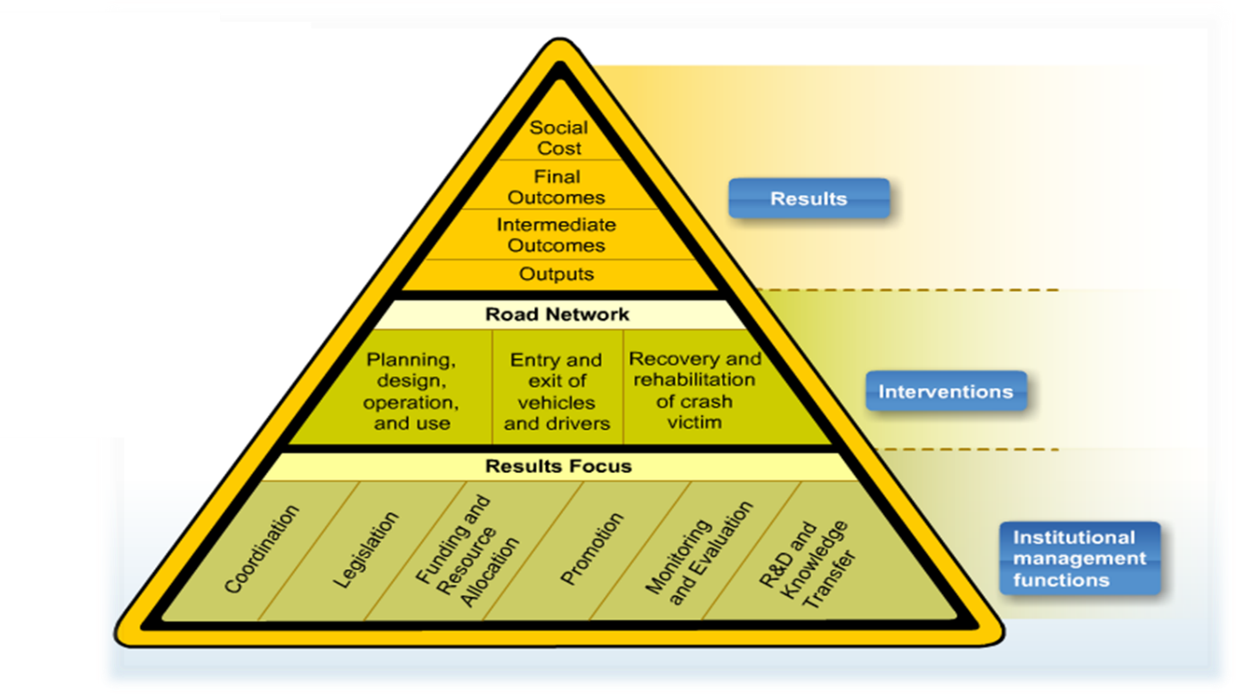
Figure 3: The concept of Road safety management system

The review should also take into account 7 strategic objectives of the EU Road Safety Policies.

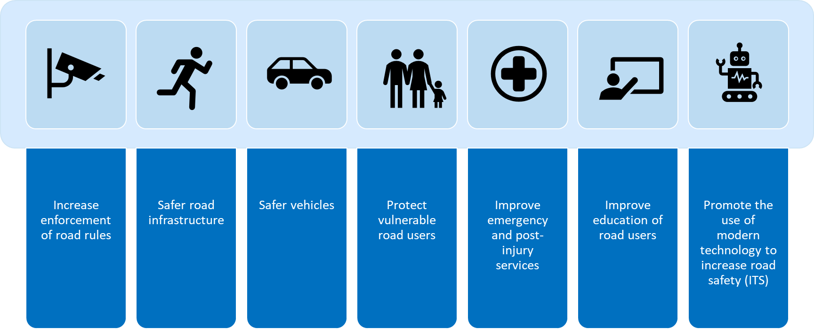
Figure 4: Seven Strategic Objectives of EU Road Safety Policy
However, it is expected that a tailored version of a standard capacity review will be undertaken under this TA. The review shall assess the problem, policies and institutional settings related to road traffic injury and assess the capacity for road traffic injury prevention in the Republic of North Macedonia. The review should take the local specificities into account and should identify recommendations that are realistic to the local country context. The review should cut across three dimensions: (i) the focus on results, (ii) safety interventions, and (iii) implementation arrangements, including institutional and regulatory implications.
The RSMCR shall be conducted through the following steps:
- Set review objective
- Prepare for review
- Appraise results focus at system level
- Appraise results focus at interventional and institutional level
- Assess lead agency role and identify capacity strengthening priorities
- Assess road safety approach at local level
- Specify investment strategy and identify Safe system implementation projects
- Translate the above findings into comprehensive Action plan
- Confirm review findings at high-level workshop
- Finalize review report
The scope of the Road Safety Management Capacity Review (RSMCR) shall be, but is not limited to, as follows:
- Review of the road safety management at system level
- Review of the road safety management at intervention level including:
  - Planning, design, operation and use of the road network
  - Entry and exit of vehicles to and from the road network
  - Entry and exit of road users to and from the road network
  - Recovery and rehabilitation of crash victims from the road network
- Review of the road safety management at institutional management functions level, guided but not limited to checklist 12 of World Bank GRSF guidelines, including:
  - Coordination – review the current mechanism for inter-agency coordination and develop a plan to facilitate interagency coordination and capacity building.
  - Legislation – review of the legal and regulatory framework related to road safety and identifies the changes that need to be made to existing laws and regulations are the new ones to be introduced.
  - Funding and resource allocation – review of the current mechanism for funding of interventions and institutional management functions and the current resource allocation procedures.
  - Promotion – review of the regularly activities for promotion of road safety with the need for a focus on results
  - Monitoring and evaluation – review the road safety performance monitoring practices and recommend changes in the monitoring and evaluation framework and in the way the data are collected and shared. Also recommend the road safety data collection to be standardized as per the EU compatible and comparable practice, while taking into considerations a potential for opening of road safety data.
  - Research and development and knowledge transfer – review of the current research and development activities and knowledge transfer practices.
- Review of the role of the lead agency and capacity strengthening priorities
- Assess road safety approach and capacities at local level
- Preparation of short-term investment strategy including
  - Identification of funding sources
  - Determination of sequencing of investments
  - Identification of minimum 3 Safe system implementation projects and preparation detailed description for each project
- Preparation of the comprehensive Action Plan that will translate all the above findings in the set of actions where to each the following is quoted, but not limited to: assigned responsible entity, time frame for delivery, approximate budget, main risk and opportunities.
- Preparation and organizing High-level Workshop to discuss and confirm review findings
The RSMCR shall include review of the road safety management at municipal (local) level with special attention to the interaction with the national level and local level capacities and performances. The RSMCR should also include recommendations for institutionalization of road safety efforts on local level and their relation to the national level and mechanisms for funding and staffing. The activity will also include a thorough analysis of the municipal road safety capacity and road safety performance and will propose municipal road safety ranking. Since there are limited data on local level road safety, the activity will require additional surveys and data collection efforts by the consultant.
The Consultant shall amend the above list based on earlier experience and findings during the work on the project. The Consultant shall also take into consideration the outputs, results and recommendations from the work on the EU funded project for establishing an executive body for road safety in North Macedonia that has recently been completed including the following activities:
- Analysis of the relevant legislation and current institutional set-up;
- Drafting the most suitable model of the executive body for road safety in North Macedonia and its internal organization, coordination structures and funding mechanisms;
- Road Safety legislation alignment report (preparation/ changes/ amendments of Law/s, By-laws and Manuals);
- Drafting of the new executive body for road safety systematisation act;
- Drafting the three-year programme/ budget for financing of the executive body;
- Proposal of the structure of unified database regarding road safety characteristics within new executive body for road safety;
- Implementing of Road Safety Audit & Inspection training.

The reports related to the EU funded project for establishing an executive body for road safety in North Macedonia are available in English.
The Consultant shall set out the basic elements of the road safety management system as defined, including available data on road safety results and trends in pre-review inception report prior to the review being conducted. The pre-review inception report shall be prepared in an executive summary form and compile all relevant information that is readily available in accordance with capacity review checklists.
The Consultant shall work through strong consultative process with relevant stakeholders. This might require informal presentations and workshops to clarify certain aspects or agree on the certain recommendations during the work on the report. Prior to start with consultative process the Consultant shall identify the relevant stakeholders and prepare Stakeholder consultation plan and schedule.
The Consultant shall organize a workshop with all stakeholders and partners consulted during the capacity review process, with objective of confirming and integrating the review findings from checklists and addressing any issues that may have remained unresolved or not been identified during the review process. The workshop shall also be focused on complementing the broad objectives and specifying the short-term investment strategy. The consultant should deliver the workshop material in advance.
The first draft of the review findings including the summary, should be submitted to the participants, prior to the workshop. During the last phase of the review, the consultant shall circulate the final draft report presenting the capacity review findings to all participants and other relevant parties for written comments and approval. Then, the consultant shall prepare a final report on Road Safety Management Capacity Review with corresponding Action Plan. The minutes from the high-level workshop together with the workshop documents and slides shall be included in the Report on Road Safety Management Capacity Review.
Required outputs for Task 1 include:
- Pre-review inception report;
- Stakeholder consultation plan and schedule;
- Report of Road Safety Management Capacity Review (RSMCR) with corresponding Action Plan;
Task 2: Improvements of road safety management capacity at municipality level (local communities)
Improving of road safety management at municipality (local) level is one of essential road safety activities in North Macedonia towards reduction of road fatalities. Therefore, under this task the Consultant shall detail and, where needed, complete additional analysis to all institutional, regulatory and technical activities identified as priority actions on local level under Task 1. It is assumed that the consultant will need to carry out the following activities, based on the outputs from Task 1:
Activity 1: Guidelines (rulebook) for transposing institutional reforms on local level
The consultant shall prepare a Guidelines for transposing institutional reforms on local level as recommended under Task 1. This might include, but is not limited to, establishing and work of local road safety bodies. The guidelines should contain at least the following parts: introductory provisions, establishment of local road safety bodies, their working arrangements, obligations and responsibilities, statutory documents, ToRs for main members of the road safety body, and formula for budget calculation. The Guidance shall also include a relevant enhancement to the current local governance framework, taking into account the size of each municipality, which will ensure strong capacity for road safety management at local level. The Consultant shall prepare the generic template document for establishment of local road safety body, work of the bodies, connection with future Road Traffic Safety Agency, reporting, transitional and final provisions, etc. The Guidelines shall be prepared and discussed with MoTC as well as with Association of the units of local self-government of the Republic of North Macedonia (ZELS) and the municipalities.
Activity 2: Operationalization of institutional changes
Under this activity the Consultant will support up to 5 selected municipalities in:
- Applying the Rulebook and establishing the local road safety body, municipalities shall be selected based on the identified local road safety capacity and road safety ranking.
- Preparation of strategic (local road safety strategy and action plan) and operational documents (council annual working program). Annual working program should be based on the analysis that took into account implementation of amending Directive to EC 96/2008, Directive (EU) 2019/1936 regarding infrastructure safety management in local communities with focus on Black Spot Management (identification and prioritization) and Road Safety Audit and Inspection, Safe road/streetscape design, Low cost - high effective measures, Traffic calming measures, School zone design, major roads passing the villages, VRU facilities, approach to prioritize and budget interventions, etc. The operational document should identify real interventions to be financed. The municipalities should be selected based on their expressed interest, and level of safety and local capacity as identified under task 1.
Activity 3: Training to the municipal staff for implementation of the institutional reforms at local level
The Consultant shall provide training to the municipal staff for implementation of the institutional reforms at local level. This training shall cover at least, but it is not limited to the following elements: road safety basics, road safety trends, road safety organizational measures at local level followed by best practice examples, establishing local road safety bodies, strategies for transition toward safer and environmentally friendly modes, data collection and monitoring and their publishing on the open data portal and at national road safety database as well as evaluation in the field of road safety, development of local road safety strategies including action plans, etc.
The consultant shall prepare training concept including detailed training plan, based on the results of previous activities that should be approved by the Client prior to delivering of the training. The training is expected to last at least five days and due to the COVID-19 emergency the Consultant shall demonstrate the possibility to organize online training. It is expected at least 80 delegates to attend the training (at least 1 delegate from each municipality). The Consultant shall provide delegates with training material including hand-outs, manuals, and other relevant material.
Outputs:
Required outputs for Task 2 include:

- Report on preparation of Guidelines for transposing institutional reforms on local level.
- Guidelines for transposing institutional reforms on local level in form of publication
- Report on preparation of Strategic and Operational documents and investment plans for 5 pilot municipalities
- Report on delivered training to the municipal staff including training plan and material.

Period of implementation of Services
The period of implementation of services is 10 months (220 days).

The Consultant shall prepare and submit their work programme for approval. The Work Programme shall include:
- Textual part where the Consultant presents a description of the following: manner in which they intend to perform the assignment, methods to be used and key activities that the Consultant intends to implement during performance of the Service. This part shall be prepared by the Consultant in free form;
- Organizational chart of the team to be engaged on performance of the Services. The chart shall be prepared in form of an appropriate diagram and shall cover all members of the team, including key and supporting staff;
- Schedule of activities (Gantt chart). Consultant shall provide the time chart of activities in form of an appropriate linear or net diagram. The diagram shall present all key and other activities under the assignment and must clearly indicate the critical time path of activities;
- Initial Work Plan for engagement of staff, including key and other staff intended for realization of the Service in appropriate forms.

Reporting Requirements
The Consultant shall submit the following reports during his assignment:
- Inception Report
- Monthly progress reports
- Deliverables from Task 1 and 2
- Final report
The Inception Report is intended to provide opinions as to whether or not the actual situation, in relation to the contract, is as described in the Terms of Reference, to describe the implementation approach to the contract, if it differs from that of his original technical proposal, to present the proposed work schedule and the planned resource mobilization and to inform about any other issues that should be identified at the earliest stages of the contract, in order to minimize any potential delays or problems during the implementation phase. The Inception Report should contain, but is not limited to, the following main elements:
- Project synopsis;
- Executive summary;
- Activities implemented (in the inception period);
- Assessment of the project start situation;
- Project Objectives, results, assumptions and risks;
- Planned activities and outputs (overall project duration and first reporting period);
- Communication and Visibility Plan;
- Project management;
- Mobilization of experts;
- Annexes.

The monthly Progress Reports are intended to assesses and inform about the project progress in implementation of activities, delivery of outputs and results and to plan the activities for the next reporting period. The Monthly Progress Reports should not be than 25 pages and should contain, but is not limited to, the following main elements:
- Project synopsis;
- Executive summary;
- Summary of progress since the project start;
- Project progress in the reporting period;
- Detailed description of communication activities;
- Summary of project planning for the remainder of the project;
- Project planning for the next reporting period;
- Annexes, project findings, recommendations;

The Final Report is intended to present in detail all carried out activities during the whole project period and to include an overall assessment of the achievement of project objectives. The report should reply to every requirement set in the Terms of Reference reflecting all activities carried out and results achieved etc. The Final Report should contain, but is not limited to, the following main elements:
- Project synopsis;
- Executive summary;
- Summary of progress since the project start;
- Project progress in the reporting period;
- Overall assessment of the performance of the project;
- Evaluation of communication activities;
- Lessons Learned;
- Annexes – outputs (final version of all deliverables) of the project.

The reports shall be prepared in Macedonian and English language and it shall consist of а hard copy and an electronic copy in editable unprotected format and PDF format. The reports shall be submitted to the Client with cover letter that contains the basic data about the Consultant, the contract and the report that is subject of delivery. The report shall be delivered in 2 (two) hard copies and 2 (two) electronic copies on CD in Macedonian language and 2 (two) hard copies and 2 (two) electronic copies on CD in English language;

The reports shall be submitted in draft version as follows:
- Inception Report shall be submitted within 30 days following the assignment start.
- Monthly Progress Report shall be submitted within 10 days following the end of each month.
- Final Report shall be submitted no later than 30 days before the end of the assignment.

The Client, shall provide comments (if any) on the draft version of the reports within 15 days upon receipt. Within 5 days of receiving comments from the Client, the consultant shall submit the final version of the reports. If no written comments are received from the Client within 15 days upon the receipt, the draft version of the reports will be considered as agreed by the Client and the Consultant shall submit the final version of the reports.

The final version of the report has to be approved by the Client within 10 days upon receipt. The Client has right to reject the final version of the report. If the final version of the report is rejected, the Consultant has to revise the report accordingly and resubmit the revised final version of the report within 10 days of receiving letter of rejection from the Client.

Project management
The Consultant shall ensure proper Project management including organising of the meetings, preparing and circulating the agenda, writing and distributing the minutes, and follow-up/implementing the Client decisions. The date of the meetings, the agenda and the necessary documents shall be set and circulated among the interested parties tentatively with a reasonable time in advance. The Consultant has to keep all documents in an electronic format as project documentation. These tasks shall be performed in co-ordination with the Client. Copyright on all reports and other material including data prepared under this contract shall remain within the Client.

Payment schedule
The payment related to the implementation of the assignment will be made according as it is specified in the Table 6.1.

Table 6.1. Payment schedule  Reports/Outputs |  | Deadline for submission
 |  | Draft | Payment upon approval of subject reports
Inception report |  | within 30 days after start of the assignment | 10% of the Contract price after the Inception Report is approved by the Client
Task 1 | - Pre-review inception report  - Stakeholder consultation plan and schedule  - Report on Road Safety Management Capacity Review and corresponding Action Plan | within 4 months after date of the acceptance of the inception report | 40% of the Contract price after the Reports are approved by the Client
Task 2 | - Report on preparation of Guidelines for transposing institutional reforms on local level.  - Guidelines for transposing institutional reforms on local level  - Report on preparation of Operational and strategic documents and investment plans for pilot municipalities  - Report on delivered training to the municipal staff including training material | Within 8 months after date of the acceptance of the inception report | 35% of the Contract price after the Reports are approved by the Client
Final report |  | within 30 days before the end of the assignment | 15% of the Contract price after the Final Report is approved by the Client

It shall be considered that the Consultant has not complied with contracted obligations and shall not be entitled to payment in accordance with the contract conditions as long as the Consultant does not completely meet the above stated reporting requirements.

Company profile and qualification criteria
For the purpose of the assignment a team of experts with relevant experience and qualifications in their subject area as indicted further below will be engaged. The Consultant firm may associate with other Consultant firm (s) in the form of a joint venture or of a sub-consultancy to complement their respective areas of expertise, strengthen the technical responsiveness of their proposal, and avail themselves to a broader pool of experts.
The qualification requirements of the Consultant firm are summarized as follows. The Consultant shall be a firm or a group of firms with following qualifications:
- Proven expertise in assignments of similar nature, scope and value, at least three (3) similar project references within last ten (10) years;
- Knowledge of national legislation, administrative system, government organization, etc.
- Proven expertise in handling policy dialog with national and local government levels in the past five (5) years;
The credibility of mentioned experience shall be presented in a list of at least three (3) similar project references within last ten (10) years with description of services provided (including information on contract value, contracting entity/client, project location/country, duration, assignment budget, percentage carried out by consultant in case of association of firms or subcontracting and main activities) and accompanied by certificates of orderly fulfilment of the contracts verified by other party from such contracts. Similar nature and scope of the assignments are those that had similar activities and goals, while similar value are the assignments that were of the similar contractual size, not necessarily of the identical scope and nature. Expertise in handling policy dialog with national and local government levels in the past five (5) years is those that provided significant policy advice to national level authorities.
The Consultant shall have the organizational capacity (it is expected that the Consultant shall have at least below listed key experts for performing activities under this assignment) and available appropriate skills among staff. The consulting team assembled to implement the project should be composed of experts with strong knowledge as per the below requirements.
Contract is a lump sum Contract. The selected Consultant shall provide the Client with a detailed-financial proposal. The estimated budget for the assignment should be justified with a detailed breakdown per activity including daily break, number of working days, reimbursable expenses (travel, per diems, accommodation, local transportation, translation, etc.).
  - Consultant’s Personnel
The Consultant shall provide adequate staff in terms of expertise and time allocation, as well as the equipment needed to complete the activities required under the scope of work and to achieve the objectives of the project in terms of time, costs and quality.
The numbers and person-months for all staff shall be included in the technical proposal and the costs in respect of these personnel are to be included in the financial proposal.
The Consultant is encouraged to use local expertise, as appropriate.
100% of the experts’ time shall be spent at the base of operations. Due to the COVID emergency, home based work is possible for tasks that do not require close work with the counterparts and only if prior approval is obtained from the Client. This will be assessed on a case-by-case basis.
Four Key experts (KE) are envisaged to carry out this assignment throughout the life of the Contract. The minimum required qualification and experience of KE is presented in Table 6.1.

Table 6.1. KE Team qualification and experience
No | Position | Relevant academic qualifications | Relevant experience | Number of experts
1 | Consultant’s Team Leader and Road  Safety  Management specialist (KE1) | University degree preferably Master in Traffic / Transport Engineering. | General experience of minimum fifteen (15) years in Traffic or Transport Engineering.  Specific experience of minimum ten (10) years in road safety management.  At least five (5) similar assignments related to road safety capacity review, road safety management, road safety training.  International experience is required. Experience in North Macedonia and knowledge in local road safety framework will be an asset.  Good command of spoken and written English is required.  Ability to communicate in Macedonian language will be considered an asset. | 1
2 | Road  Safety  Specialist (KE2) | University degree preferably Master in Traffic / Transport Engineering. | General experience of minimum ten (10) years in Traffic or Transport Engineering.  Specific experience of minimum seven (7) years in road safety management.  At least 3 (three) similar assignments related to implementation of road safety measures in local communities, road safety management and training.  Experience in North Macedonia and knowledge in local road safety framework will be an asset.  Good command of spoken and written English is required.  Knowledge of Macedonian language will be considered an asset. | 1
3 | Policy  Expert  (KE3) | University in Law or Transport policy or Traffic / Transport Engineering or equivalent. | General experience of minimum ten (10) years in policy and legal advisory related to the road safety management.  At least two (2) similar assignments related to policy advisory law analysis and preparation of laws related to the road traffic, preferably road safety.  Knowledge of local legal system and legislation is required.  Knowledge of Macedonian language will be considered an asset. | 1
4 | Training Expert  (KE4) | University degree in  Traffic / Transport Engineering or equivalent. | General experience of minimum ten (10) years in Traffic engineering or Transport Engineering.  Specific experience of at least seven (7) years in road safety with at least three (3) assignments related to performing of road safety trainings.  Good command of spoken and written English is required.  Knowledge of Macedonian language will be an asset. | 1

The Consultant shall submit the curriculum vitae of key experts along with copies of their academic qualifications.
The key staff specified in the Proposal cannot be replaced, except in cases and under conditions clearly stated in General and Special Conditions of the Contract.
In addition to the KE, the Consultant shall propose non-key experts that will support the KE team. Their CVs will not be evaluated but will need to be approved by the Client.

Law and Language
For implementation of contracts under the Project, laws of the North Macedonia shall apply (unless in case of conflict with provisions of the loan agreements and relevant guidelines in which case provisions of those shall prevail).
Within execution of the Services, the Consultant shall comply with all requirements referred to by the loan agreements, project agreements and relevant guidelines, rulebooks and manuals in addition to appliance of relevant domestic regulations.
Official language of the contract is English. However, the Consultant shall maintain written and oral correspondence with relevant institutions in the North Macedonia in Macedonian language. The communication at the workshops with stakeholders should be conducted with simultaneous translation in Macedonian language and vice versa. The Consultant shall be obliged to provide all translations into English Language and Macedonian language as may be necessary.

The World Bank Group, Project Appraisal Document for North Macedonia Local Roads Connectivity Project
The World Bank Group, Project Appraisal Document for North Macedonia Local Roads Connectivity Project
European Commission, retrieved from https://ec.europa.eu/eurostat/statistics-explained/index.php/Enlargement_countries_transport_statistics#Motorisation_rate, on February 29, 2020
State Statistical Office of Republic of North Macedonia, retrieved from http://makstat.stat.gov.mk/PXWeb/pxweb/en/MakStat/MakStat__Transport__PrevezeniPatniciStoki, on February 26, 2020
European Commission Technical Assistance, 2018, Draft National Transport Strategy
European Commission Technical Assistance, 2018, Draft National Transport Strategy
CONNECTA, 2018, Preparation of Road Safety Inspection and Audit Plans for core/comprehensive road network in Western Balkans (WB6) and Pilots
Study "Monitoring of the road safety strategies in SEETO members and draft a regional short term action plan, 2017, Final Report
http://www.who.int/violence_injury_prevention/publications/road_traffic/world_report/en/
https://www.worldbank.org/en/topic/transport/publication/road-safety-management-capacity-review-guidelines
EuropeAid/138778/DH/SER/Multi-Project: "Technical Assistance for establishing an executive body for road safety in North Macedonia", implemented by Planet S.A.

